#Insert review title#: A systematic review
Primary reviewer name¹
Secondary reviewer name²
1 Primary reviewer affiliation
2 Secondary reviewer affiliation

Corresponding author:
Reviewer name
Email xx@xx.xx.xx

Executive summary
Background
#Insert text#
Objectives
Inclusion criteria
Types of participants
Types of intervention(s)/phenomena of interest
Types of studies
Types of outcomes
Search strategy
Methodological quality
Data extraction
Data synthesis
Results
Conclusions
Implications for practice
Implications for research
Keywords
Table 1: Summary of findings
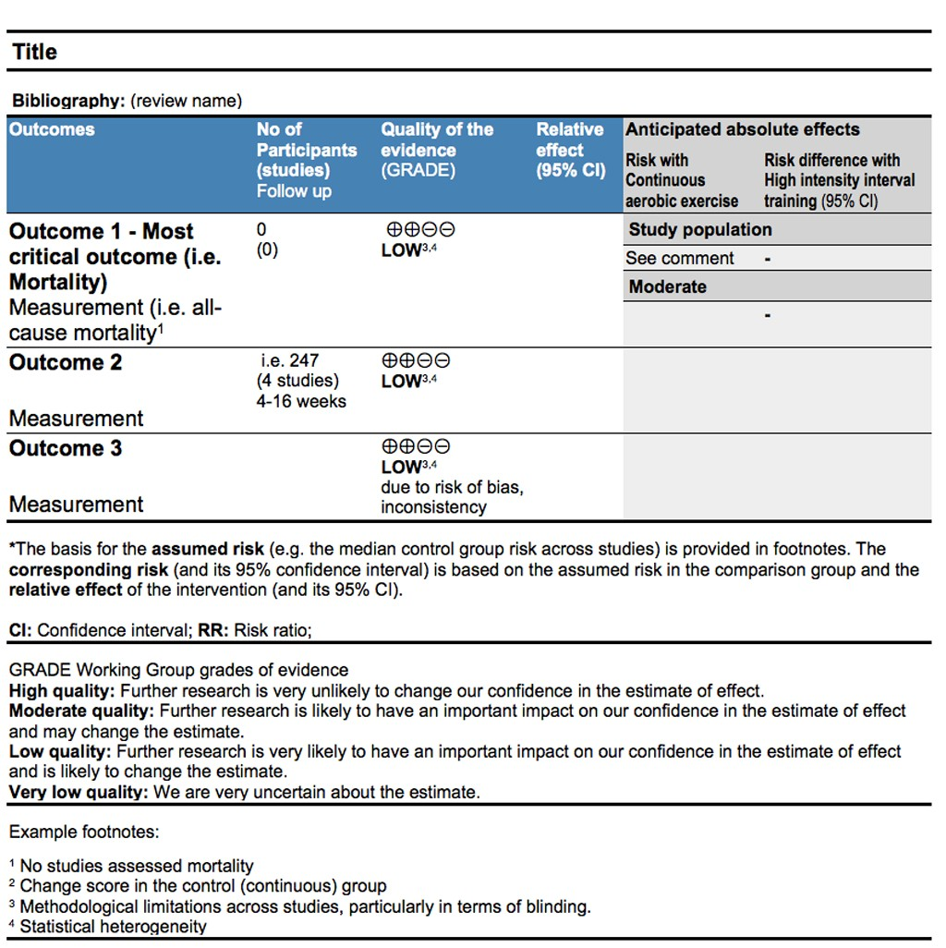
OR
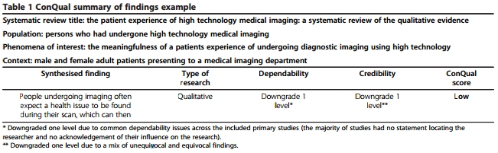

Introduction
Background
#Insert text#
This review was conducted according to an a priori published protocol. #Insert reference for protocol#
Subheading (if required)
Objectives
The quantitative objective/s is/are to identify the effectiveness of #state intervention# on #state outcome#
More specifically, the objectives are to identify the effectiveness of #insert text# on #insert text# in #insert text#
The qualitative objective/s is/are to identify the meaningfulness/appropriateness of #modify text as appropriate# of #phenomena of interest#.
The textual objective/s is/are to identify the findings of #describe#
The economic objective/s of this review is/are to identify the cost effectiveness, cost benefit, cost minimization, cost utility #modify text as appropriate# of #state intervention# on #state outcome#
More specifically, the objectives are to identify the evidence on:
The cost effectiveness, cost benefit, cost minimization, cost utility #modify text as appropriate# of #insert text# compared to #insert text# on #insert text# in #insert text#
Inclusion criteria
Types of participants
This review considered studies that included #describe participants#
Types of intervention(s)/phenomena of interest
This review considered studies that evaluated #insert text#
Types of studies
The quantitative component of the review considered both experimental and epidemiological study designs including randomized controlled trials, non-randomized controlled trials, quasi-experimental studies, before and after studies, prospective and retrospective cohort studies, case control studies and analytical cross sectional studies #modify text as appropriate# for inclusion. The quantitative component of the review also considered descriptive epidemiological study designs including case series, individual case reports and descriptive cross sectional studies #modify text as appropriate# for inclusion.
The qualitative component of the review considered studies that focused on qualitative data including, designs such as phenomenology, grounded theory, ethnography, action research and feminist research #modify text as appropriate#.
In the absence of research studies, other text such as opinion papers and reports were considered. The textual component of the review considered expert opinion, discussion papers, position papers and other text #modify text as appropriate#.
The economic component of the review will consider cost effectiveness, cost benefit, cost minimization, cost utility #modify text as appropriate# studies.

Types of outcomes
This review considered studies that included the following outcoms: #insert text#
Search strategy
The search strategy aimed to find both published and unpublished studies. A three-step search strategy was utilised in this review. An initial limited search of MEDLINE and CINAHL #change as appropriate# was undertaken followed by analysis of the text words contained in the title and abstract, and of the index terms used to describe article. A second search using all identified keywords and index terms was undertaken across all included databases. Thirdly, the reference list of all identified reports and articles was searched for additional studies. Studies published in #insert language(s)# were considered for inclusion in this review. Studies published #insert dates# were considered for inclusion in this review.
The databases searched included:
#insert text#
The search for unpublished studies included:
#insert text#
Initial keywords to be used were:
#insert text#
The full search strategy is provided in Appendix #modify number as appropriate#.
Method of the review
Quantitative papers selected for retrieval were assessed by two independent reviewers for methodological validity prior to inclusion in the review using standardized critical appraisal instruments from the Joanna Briggs Institute Meta Analysis of Statistics Assessment and Review Instrument (JBI-MAStARI) (Appendix #number as appropriate#). Any disagreements that arose between the reviewers were resolved through discussion, or with a third reviewer.
Qualitative papers selected for retrieval were assessed by two independent reviewers for methodological validity prior to inclusion in the review using standardized critical appraisal instruments from the Joanna Briggs Institute Qualitative Assessment and Review Instrument (JBI-QARI) (Appendix #number as appropriate#). Any disagreements that arose between the reviewers were resolved through discussion, or with a third reviewer.
Textual papers selected for retrieval were assessed by two independent reviewers for authenticity prior to inclusion in the review using standardized critical appraisal instruments from the Joanna Briggs Institute Narrative, Opinion and Text Assessment and Review Instrument (JBI-NOTARI) (Appendix #number as appropriate#). Any disagreements that arose between the reviewers were resolved through discussion, or with a third reviewer.
Economic papers selected for retrieval were assessed by two independent reviewers for methodological validity prior to inclusion in the review using standardized critical appraisal instruments from the Joanna Briggs Institute Analysis of Cost, Technology and Utilisation Assessment and Review Instrument (JBI-ACTUARI) (Appendix #number as appropriate#). Any disagreements that arose between the reviewers were resolved through discussion, or with a third reviewer.
Data extraction
Quantitative data were extracted from papers included in the review using the standardized data extraction tool from JBI-MAStARI (Appendix #number as appropriate#). The data extracted included specific details about the interventions, populations, study methods and outcomes of significance to the review question and specific objectives #modify text as appropriate#.
Qualitative data were extracted from papers included in the review using the standardized data extraction tool from JBI-QARI (Appendix #number as appropriate#). The data extracted included specific details about the interventions, populations, study methods and outcomes of significance to the review question and specific objectives #modify text as appropriate#.
Textual data were extracted from papers included in the review using the standardized data extraction tool from JBI-NOTARI (Appendix #number as appropriate#). The data extracted included specific details about the interventions, populations, study methods and outcomes of significance to the review question and specific objectives #modify text as appropriate#.
Economic data were extracted from papers included in the review using the standardized data extraction tool from JBI-ACTUARI (Appendix #number as appropriate#). The data extracted included specific details about the interventions, populations, study methods and outcomes of significance to the review question and specific objectives #modify text as appropriate#.
Data synthesis
Quantitative data were, where possible, pooled in statistical meta-analysis using JBI-MAStARI. All results will be subject to double data entry. Effect sizes expressed as odds ratio (for categorical data) and weighted mean differences (for continuous data) and their 95% confidence intervals were calculated for analysis #modify text as appropriate#. Heterogeneity was assessed statistically using the standard Chi-square and also explored using subgroup analyses based on the different quantitative study designs included in this review. Where statistical pooling was not possible the findings were presented in narrative form including tables and figures to aid in data presentation where appropriate.
Qualitative research findings were, where possible, pooled using JBI-QARI. This involved the aggregation or synthesis of findings to generate a set of statements that represent that aggregation, through assembling the findings rated according to their quality, and categorizing these findings on the basis of similarity in meaning. These categories were then subjected to a meta-synthesis in order to produce a single comprehensive set of synthesized findings that could be used as a basis for evidence-based practice. Where textual pooling was not possible the findings were presented in narrative form.
Textual papers were, where possible,pooled using JBI-NOTARI. This involved the aggregation or synthesis of conclusions to generate a set of statements that represent that aggregation, through assembling and categorizing these conclusions on the basis of similarity in meaning. These categories were then subjected to a meta-synthesis in order to produce a single comprehensive set of synthesized findings that could be used as a basis for evidence-based practice. Where textual pooling was not possible the conclusions will be presented in narrative form.
Economic findings were, where possible pooled using JBI-ACTUARI and presented in a tabular summary. Where this was not possible, findings were presented in narrative form.
Results
Description of studies
#Insert text pertaining to searching and study selection here. Consider alternative heading of “Study Selection”. Refer to Study selection flow chart in the text#.

Number of additional records identified through other sources (N=X)

Number of records identified through a systematic search (N=X)

Identification

Number of records after duplicates removed (N=x)

Screening

Number of records screened (N=x)

Number of records excluded (N=x)

Number of full-text articles assessed for eligibility (N=x)

Number of articles excluded on reading full-text (N=X)

Eligibility

Number of articles excluded on critical appraisal (N=x)

Number of articles assessed for quality (N=X)

Number of articles included
(N=x)

Included

From: Moher D, Liberati A, Tetzlaff J, Altman DG, The PRISMA Group (2009). Preferred Reporting Items for Systematic
Reviews and Meta-Analyses: The PRISMA Statement. PLoS Med 6(6): e1000097. doi:10.1371/journal.pmed1000097

Figure #: Titles and captions should be concise but comprehensive. The figure must be understandable without reference to the text. PRISMA flow diagram of search and study selection process (please use editable text NOT an image)

#Insert text describing characteristics of included studies. Refer to table of characteristics of included studies (Appendix #) here#.

Methodological quality
#Insert text#

Table #: Assessment of methodological quality
Citation | Q1 | Q2 | Q3 | Q4 | Q5 | Q6 | Q7 | Q8 | Q9 | Q10
Chen YC, Chou SS, Lin  LH, Wu LF, 2006 | Y | N | U | U | N | Y | Y | Y | Y | Y
Hiebert JM, Brown A, Anderson RG, Halfacre S, Rodeheaver GT, Edlich PF, 1981 | N | N | N | Y | N | U | Y | Y | Y | U
Kocan MJ, Hickisch SM,  1986 | Y | N | N | U | U | U | U | Y | Y | U
MacLeod JB, Lefton J, Houghton D, Roland C, Doherty J, Cohn SM et al., 2007 | Y | N | Y | U | U | Y | Y | Y | Y | Y
Serpa LF, Kimura M, Faintuch J, Ceconello I,  2003 | U | N | N | U | N | N | Y | Y | Y | U
Taylor TT, 1982 | Y | N | N | U | N | U | Y | Y | Y | N
% | 66.67 | 0.00 | 16.67 | 16.67 | 0.00 | 33.33 | 83.33 | 100.00 | 100.00 | 33.33

Findings of the review
#Insert text#
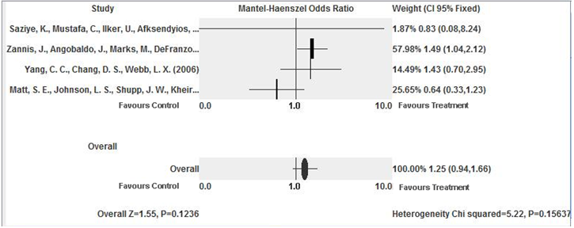
Figure #: Titles and captions should be concise but comprehensive. The figure must be understandable without reference to the text. For example: The effect of the interevention compared with the comparator on the outcome.

Findings | Categories | Synthesized findings
Finding | Category | Synthesized finding
Finding
Finding | Category
Finding
Finding | Category | Synthesized finding
Finding
Finding | Category
Finding
Finding
Finding | Category
Finding
Finding | Category | Synthesized finding
Finding
Finding | Category
Finding
Figure #: Results of metasynthesis of qualitative research findings (Please use editable text not an image)

Discussion
#insert text#
Subheading (if required)

Conclusion
#Insert text#
Implications for practice
#Implications for practice must use JBI Grades of Recommendation#
Implications for research
#Insert text#

Conflict of interest
#Insert text#

Acknowledgements
#Insert text#

References
1. Rorabeck CH. The treatment of compartment syndromes of the leg. J Bone Joint Surg Br. 1984;66(1):93-7.
2. McQueen MM, Court-Brown CM. Compartment monitoring in tibial fractures. The pressure threshold for decompression. J Bone Joint Surg Br. 1996;78(1):99-104.
3. Bourne RB, Rorabeck CH. Compartment syndromes of the lower leg. Clin Orthop Relat Res. 1989(240):97-104.
4. Sheridan GW, Matsen FA, 3rd. Fasciotomy in the treatment of the acute compartment syndrome. J Bone Joint Surg Am. 1976;58(1):112-5.
5. Finkelstein JA, Hunter GA, Hu RW. Lower limb compartment syndrome: course after delayed fasciotomy. J Trauma. 1996;40(3):342-4.
6. McQueen M. Acute compartment syndrome. Acta Chir Belg. 1998;98(4):166-70.
7. Fitzgerald AM, Gaston P, Wilson Y, Quaba A, McQueen MM. Long-term sequelae of fasciotomy wounds. Br J Plast Surg. 2000;53(8):690-3.
8. Giannoudis PV, Nicolopoulos C, Dinopoulos H, Ng A, Adedapo S, Kind P. The impact of lower leg compartment syndrome on health related quality of life. Injury. 2002;33(2):117-21.
9. Velmahos GC, Theodorou D, Demetriades D, Chan L, Berne TV, Asensio J, et al. Complications and nonclosure rates of fasciotomy for trauma and related risk factors. World J Surg. 1997;21(3):247-52; discussion 53.
10. Blackman PG. A review of chronic exertional compartment syndrome in the lower leg. Med Sci Sports Exerc. 2000;32(3 Suppl):S4-10.
11. Rorabeck CH, Fowler PJ, Nott L. The results of fasciotomy in the management of chronic exertional compartment syndrome. Am J Sports Med. 1988;16(3):224-7.
12. Ojike NI, Roberts CS, Giannoudis PV. Compartment syndrome of the thigh: a systematic review. Injury. 2010;41(2):133-6.
13. Ojike NI, Roberts CS, Giannoudis PV. Foot compartment syndrome: a systematic review of the literature. Acta Orthop Belg. 2009;75(5):573-80.
14. Hayakawa H, Aldington DJ, Moore RA. Acute traumatic compartment syndrome: a systematic review of results of fasciotomy. Trauma. 2009;11:5-35.
15. Tiwari A, Haq AI, Myint F, Hamilton G. Acute compartment syndromes. Br J Surg. 2002;89(4):397-412.
16. Kalyani BS, Fisher BE, Roberts CS, Giannoudis PV. Compartment syndrome of the forearm: a systematic review. J Hand Surg Am. 2011;36(3):535-43..
17. Berman SS, Schilling JD, McIntyre KE, Hunter GC, Bernhard VM. Shoelace technique for delayed primary closure of fasciotomies. Am J Surg. 1994;167(4):435-6.
18. Cohn BT, Shall J, Berkowitz M. Forearm fasciotomy for acute compartment syndrome: a new technique for delayed primary closure. Orthopedics. 1986;9(9):1243-6.
19. Harris I. Gradual closure of fasciotomy wounds using a vessel loop shoelace. Injury. 1993;24(8):565-6.
20. Sawant MR, Hallett JP. The paper-clip modification to the vessel loop 'shoelace' technique for delayed primary closure of fasciotomies. Injury. 2001;32(8):619-20.
21. Janzing HM, Broos PL. Dermatotraction: an effective technique for the closure of fasciotomy wounds: a preliminary report of fifteen patients. J Orthop Trauma. 2001;15(6):438-41.
22. Harrah J, Gates R, Carl J, Harrah JD. A simpler, less expensive technique for delayed primary closure of fasciotomies. Am J Surg. 2000;180(1):55-7..
23. Barnea Y, Gur E, Amir A, Leshem D, Zaretski A, Miller E, et al. Delayed primary closure of fasciotomy wounds with Wisebands, a skin- and soft tissue-stretch device. Injury. 2006;37(6):561-6.
24. Wiger P, Blomqvist G, Styf J. Wound closure by dermatotraction after fasciotomy for acute compartment syndrome. Scand J Plast Reconstr Surg Hand Surg. 2000;34(4):315-20.
25. Govaert GA, van Helden S. Ty-raps in trauma: a novel closing technique of extremity fasciotomy wounds. J Trauma. 2010;69(4):972-5..
26. Chiverton N, Redden JF. A new technique for delayed primary closure of fasciotomy wounds. Injury. 2000;31(1):21-4.

Appendix I: Search strategy

PubMed (pubmed.gov)
Search on #Insert date#
Search | Query
#1 | Stillbirth*[tw] OR Stillborn*[tw] OR Still-birth*[tw] OR Still-born*[tw] OR Fetal death*[tw] OR Foetal death*[tw] OR Fetus death*[tw] OR Foetus death*[tw] OR Intrauterine death*[tw] OR Utero death*[tw] OR Perinatal death*[tw] OR Antepartum death*[tw] OR Antenatal death*[tw] OR Intrapartum death*[tw] OR Prenatal death*[tw] OR "Stillbirth"[Mesh] OR "fetal death"[Mesh] OR "Perinatal Mortality"[Mesh]
#2 | Psychosocial[tiab] OR Psycholog*[tiab] OR Psychotherap*[tiab] OR Psychopath*[tiab] OR Social[tiab] OR Griev*[tiab] OR Grief[tiab] OR Anxiety[tiab] OR Emotion*[tiab] OR Wellbeing[tiab] OR Well-being[tiab] OR Mourn*[tiab] OR Depressi*[tiab] OR Bereave*[tiab] OR Guilt[tiab] OR Cope*[tiab] OR Coping[tiab] OR Stress*[tiab] OR "Counseling"[Mesh] OR "Aftercare"[Mesh] OR "Social Support"[Mesh] OR "Adaptation, Psychological"[Mesh] OR "parents/psychology*"[Mesh] OR "mothers/psychology*"[Mesh] OR "Women/psychology"[Mesh] OR "Parent-Child Relations"[Mesh] OR Professional-Patient Relations*[Mesh] OR "Fathers/psychology"[Mesh] OR "Depression"[Mesh] OR "Depressive Disorder, Major"[Mesh] OR "Emotions"[Mesh] OR "Anxiety"[Mesh] OR "Anxiety Disorders"[Mesh] OR "Bereavement"[Mesh] OR "Grief"[Mesh] OR "Professional-Family Relations"[Mesh] OR "Guilt"[Mesh] OR "Family/psychology"[Mesh] OR "Mental Health"[Mesh] OR "Psychotherapy"[Mesh] OR "Psychology"[Mesh]
#3 | #1 AND #2
Limit to #insert date, language, species etc limits#

Appendix II: Appraisal instruments
QARI appraisal instrument
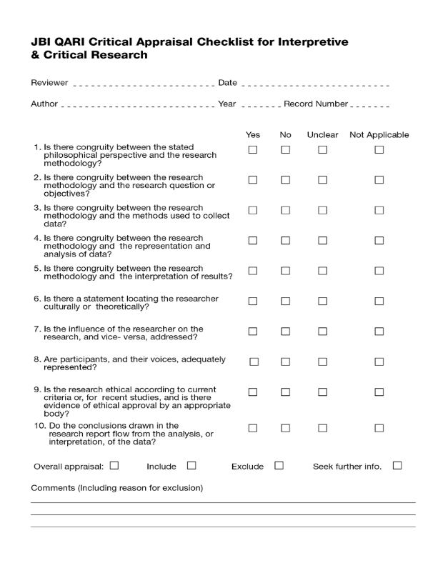
MAStARI appraisal instrument
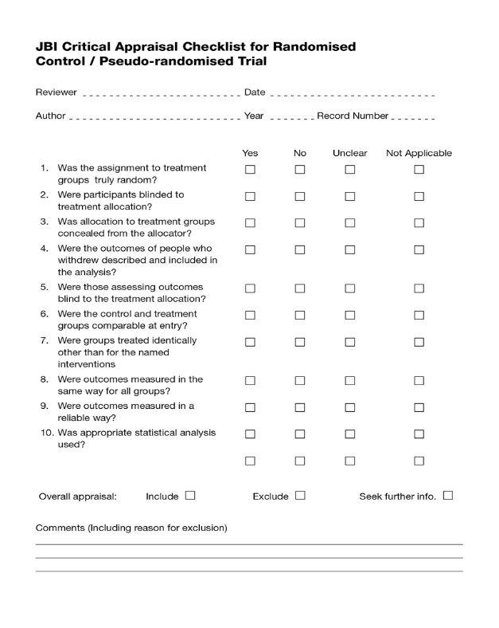
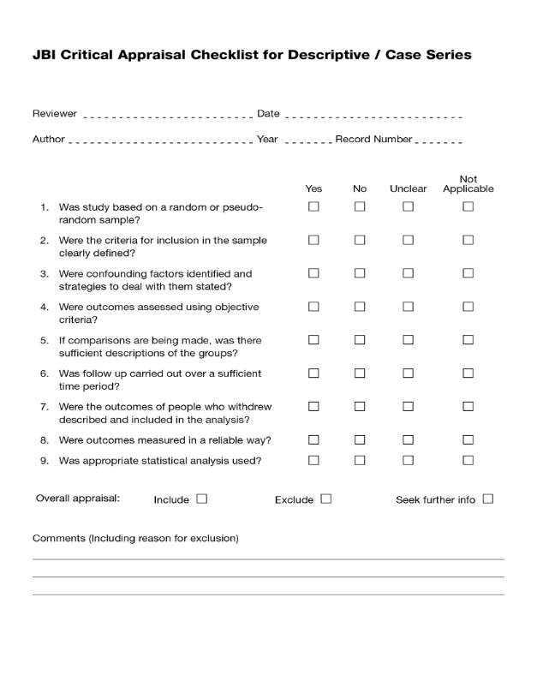
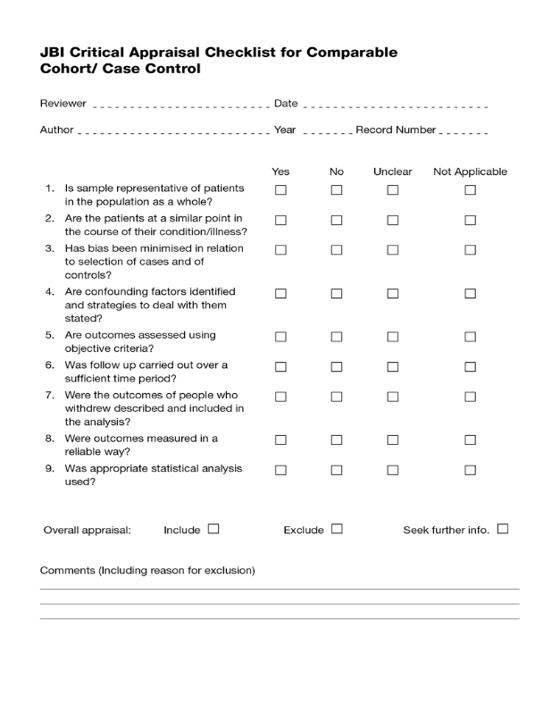
ACTUARI appraisal instrument
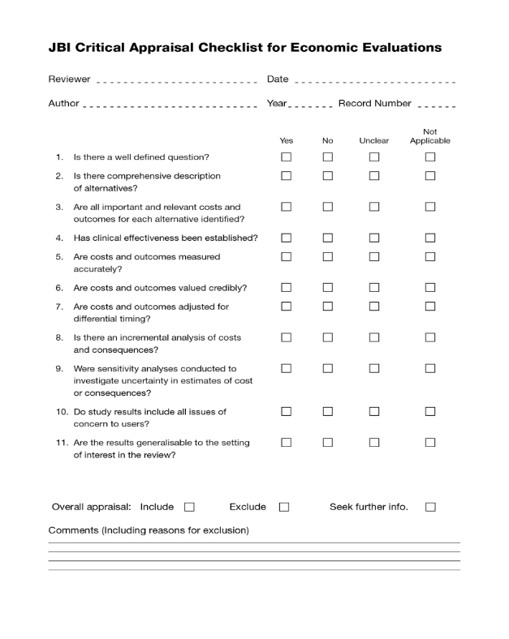
NOTARI appraisal instrument

Appendix III: Data extraction instruments
QARI data extraction instrument
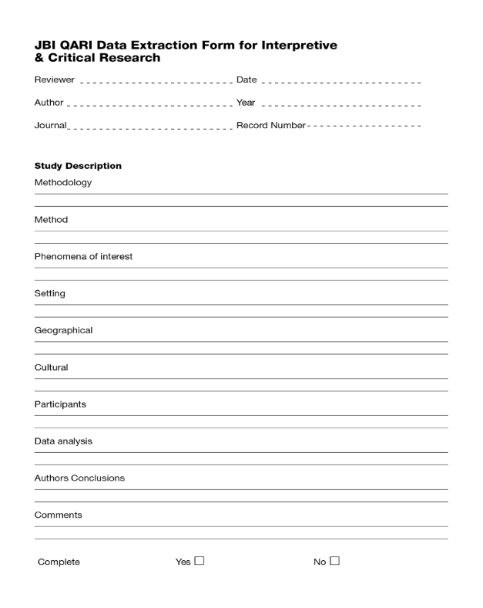
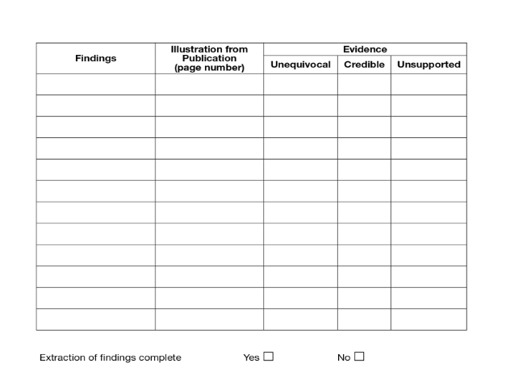
MAStARI data extraction instrument
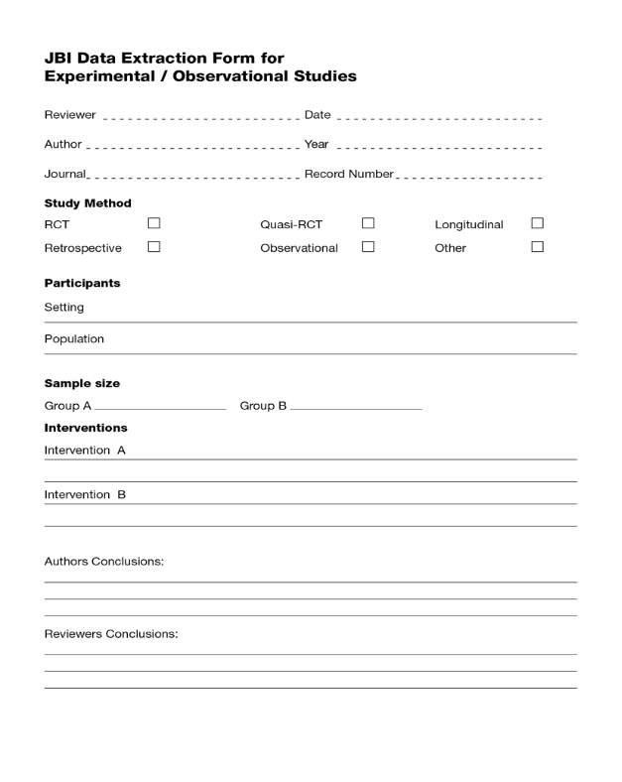
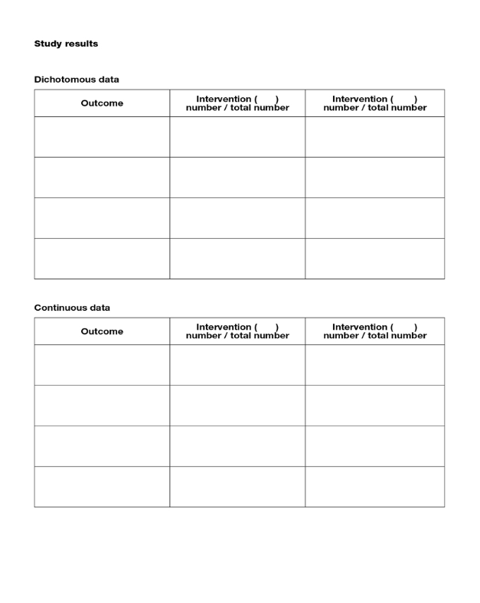
ACTUARI data extraction instrument
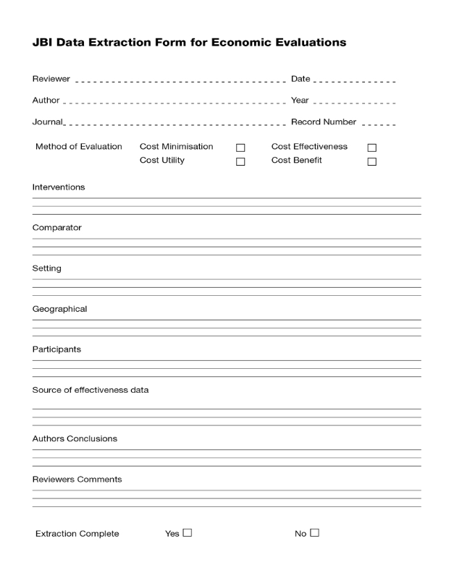
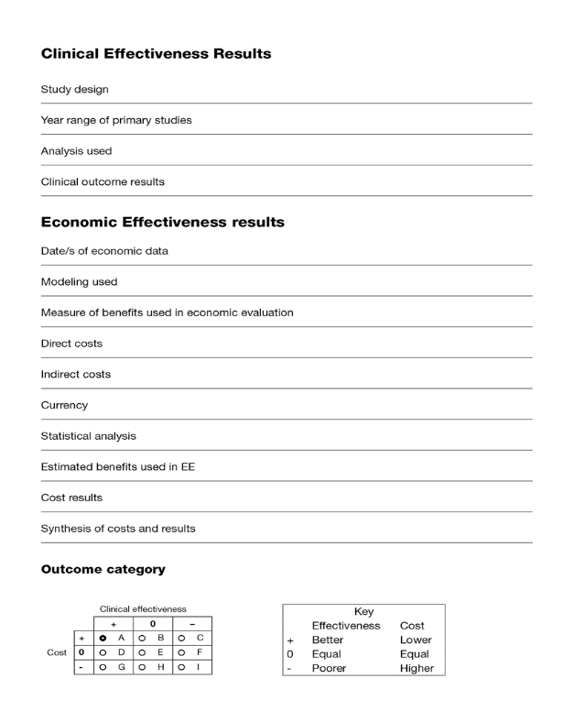
NOTARI data extraction instrument
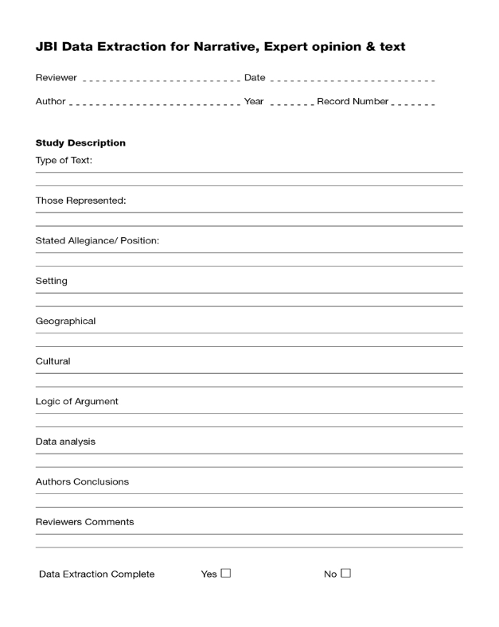

Appendix IV: Excluded studies
#Insert text of excluded studies. Where studies have been excluded based on not meeting inclusion criteria or being of insufficient quality, these need to be listed separately#.
Boxer LK and Buchman SR. An alternative method of closure of fasciotomy wounds: healing by secondary intention
Reason for exclusion: Methodology lacked rigor including criteria for inclusion in study not defined and no length of stay recorded.
Harrah J, Gates R, Carl J, Harrah JD. A simpler, less expensive technique for delayed primary closure of fasciotomies
Reason for exclusion: Paper described a wound management technique but data about the patients the method was used on was not described clearly enough in the paper.
Heemskerk J and Kitslaar P. Acute compartment syndrome of the lower leg: retrospective study on prevalence, technique, and outcome of fasciotomies
Reason for exclusion: Outcomes of interest not clearly defined.
Schwartz Jr JT, Brumback RJ, Lakatos R, Poka A, Bathon GH, Burgess AR. Acute compartment syndrome of the thigh. A spectrum of injury
Reason for exclusion: This study reviewed patients who developed thigh compartment syndrome overall, therefore wound treatment was not the main focus of the paper and most outcomes of interest were not documented.

Appendix V: List of study findings/conclusions/Characteristics of included studies
MAStARI
Study | Methods | Participants | Intervention A | Intervention B | Notes

